RailCab
User Interface Design

Main Window
This window contains the primary controls of the simulation.
The bottom part of the screen is used for different types of panels.
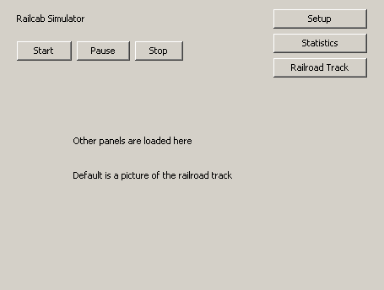

Railroad diagram
This resembles the picture that will be seen in the Main Window. Clicking on a StationNode will select the corresponding Station. The bottom part of the Main Window will then be occupied by the Station Panel.
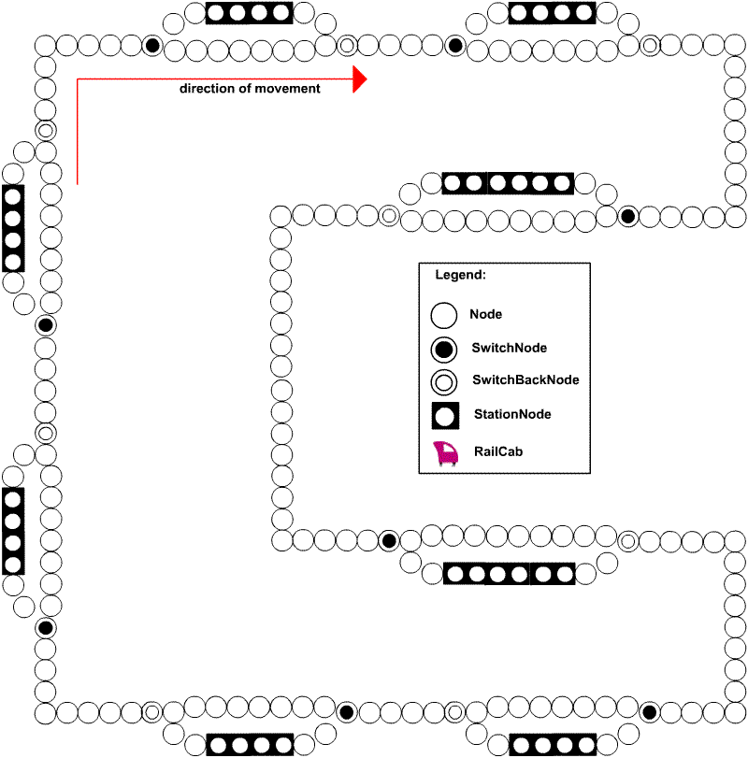

Station Panel
This panel allows the user to see the Station’s information. The items in the list can be selected and removed with the “Remove selected” button. Pressing the “Add group” button will take you to the Group Panel.
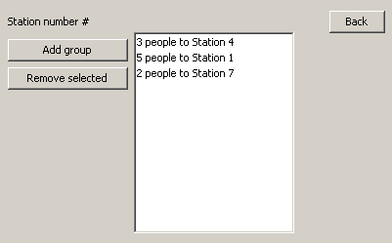

Group Panel
Here the user can enter information about the new group. The “Add group” button adds the newly created group to the corresponding Station.
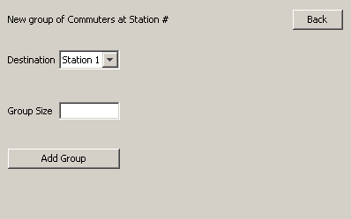
Setup Panel
This panel is opened when the user has clicked the “Setup” button in the Main Window.
It contains the settings of the simulation.
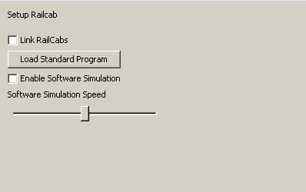

Statistics Panel
Clicking the “Statistics” button in the Main Window opens this panel.
Simulations statistics can be viewed here.
